

ITBW21 - Visual Analytics Project

Final Report

|  |  |
| --- | --- |
| **Submitted by:** | Andrew 212579B [Group Leader]  Shermaine 213276Q  Shi Min 201357X  Zhang Xiang 210896X |
| **Module Group:** | ITBW21-01 |
| **Supervisors:** | Ms. Joanne Foo & Ms. Joscelyne Chan |
| **Latest Report Amendment Date:** | 20th February 2022 |

Table of Contents

Executive Summary 2

Project Plan 3

Project Team Organization and Software used 3

Gantt Chart 3

Data Understanding, Visualization, and Modeling 4

Dashboard 4

Transportation 5

Security 7

Consumer Goods 9

Education 13

Healthcare 16

Recreation 21

Economy 23

Problems Encountered 25

Future Enhancements 26

Conclusion 26

Appendix 27

# Executive Summary

Is Singapore a good place to live or work in?

Our group decided on a stakeholder group comprised of Singaporean graduates aged 16 to 21, holding either an O Level certificate, Diploma, or both.

Through this project, we broke down the assertion into different factors and unraveled this statement by analyzing its different elements, then united them to produce a complete answer to this question.

Based on our stakeholder’s interview, we learned that many are unsure of Singapore's suitability as a place to live or work in. While many of them have slight dissatisfaction and unhappiness with their quality of life, they are also satisfied with what they have. Hence, we have created the following visuals in response to our stakeholders' desire for overall affordability of all factors, accessibility to goods and services, subsidies, high-quality services, frequency of services, more and equal opportunities, and smooth transportation.

The several factors that will be discussed include transportation, security, consumer goods, education, healthcare, recreation, and the economy. With that, our project aims to provide stakeholders with a better grasp of the various factors affecting Singapore's quality of life, as well as a conclusion we have made as a whole.

The following pages (here) will provide a deeper analysis that reveals different details of the above factors and also the proof or disproof of the points mentioned by our stakeholders.

Lastly, we would recommend that the stakeholders appreciate what they have and open their minds to issues such as criminal cases, affordability, and accessibility so they will be up to date with Singapore's efforts in improving our quality of life. Therefore, learning how to work around and manage different problems.

# Project Plan

## Project Team Organization and Software used

* Some software tools utilized by our team include PowerBI, Github, and Excel. Below are the tasks and factors assigned to each member of the team.

|  |  |  |
| --- | --- | --- |
| **Name** | **Task** | **Factor(s)** |
| Andrew | Slides Control & Communication between Team & Supervisor | Transportation & Security |
| Zhang Xiang | Gantt Chart | Consumer Goods & Education |
| Shermaine | Design & Merging | Healthcare |
| Shi Min | Report Template & Adjustments | Recreation & Economy |

## Gantt Chart

# 

# Data Understanding, Visualization, and Modeling

## Dashboard

Figure 0 uses the following visuals:

1. Line charts
2. Pie chart
3. Clustered bar chart

As the majority of our stakeholders expressed grave concerns about the affordability of living a good quality of life in Singapore, our dashboard hence examines the affordability of transport, consumer goods, education, healthcare, and recreation, which will be explained in more detail in the following pages of our report.

Group special features:

1. Navigation panel
   1. From the navigation panel, users can access the following factors, dashboard, and conclusion. Additionally, each icon is accompanied by a tooltip for a better understanding of the icon.
2. Page navigation
   1. For the following factors with many pages, a page navigation is created with a dropdown slicer and a search icon that takes the user to the following "searched" page based on the slicer. By doing so, users are able to navigate between different pages of a factor quickly and easily.

## Transportation

This section is documented by Andrew.

Figure 1.1 uses the following two visuals:

1. Tornado chart: Number of buses catering to the passenger population
2. Line Chart: Student’s transportation fare over the year.

Based on these visuals, stakeholders can gather the following insights:

1. Is the transportation fare of students in Singapore getting cheaper?
2. Are there sufficient buses to cater to the passenger population?

The datasets are used from:

1. Statista.sg (Transportation)
2. Land Transport Guru (Fare tables)
3. SMRT (Fare tables)

The visuals in Figure 1.1 allow stakeholders to determine whether Singapore is a good and affordable place to live in, given the transportation fare of students and buses catered to the passenger population.

Recommendation: I would recommend that the government reduce the transportation fare for students or schools to cover a certain cost of students’ traveling fare. For students, I would recommend them to find a traveling path that would minimize their traveling fares even if it causes a slight delay for their travel.

Figure 1.2 and Figure 1.3 uses the following two visuals:

1. Map Chart
2. Card

Based on these visuals, stakeholders can gather the following insights:

1. Is public transport sufficient in Singapore?
2. Is public transport accessible to all?

The datasets are used from:

1. Mapcarta (Location of MRT/LRT/Bus stations)
2. Land Transport Authority (LTA) (Name of Bus and MRT stations)

Special Features:

1. Hovering over the Delay Card (Figure 1.4) allows stakeholders to view the breakdown of delays over the year.

The maps above allow stakeholders to see the spread of public transport in Singapore. Figure 1.2 shows the spread of MRT/LRT stations while Figure 1.3 shows the spread of Bus Interchange.

These maps can prove whether Singapore is a good place to live/work in given its transportation network catered to residents in different parts of Singapore.

The delay card for MRT Network on the MRT/LRT map page allows stakeholders to know the average number of delays over a span of 6 years. Stakeholders may associate a well-maintained transportation system with fewer delays to be a good place to live/work in as it allows traveling without many delays.

## Security

This section is documented by Andrew.

Figure 2.1 uses the following visual:

1. Line Chart

Based on these visuals, stakeholders can gather the following insights:

1. Is security in Singapore well-maintained?
2. Is the government doing enough to arrest and prevent these crime cases?

The datasets are used from:

1. Data.gov.sg (Society 🡪 Crime)

Special Features:

1. Figure 2.2: Hovering over the “Total Number of Crimes OTY'' chart allows stakeholders to view the breakdown of crime cases and be aware of which crime is most prevalent.
2. Figure 2.3: Stakeholders can right-click and analyze the chart to find out which crime categories led to the increase or decrease of values between 2 years.

The top visual of Figure 2.1, with a single red line, shows the total number of criminal cases over the year. The bottom two visuals are placed side by side for stakeholders to easily compare the number of arrests (on the left) to the number of victims of the same crime (on the right). With the number of victims of certain crimes, stakeholders will be aware of the crimes that could possibly happen to them as the stakeholders are within the victim’s age group. They will also be able to see if there has been an increasing/decreasing trend of certain crimes toward people in their age group and arrest cases.

With the visuals in Figure 2.1, stakeholders can determine whether Singapore’s security is well-maintained based on the total number of crimes and arrests compared to victims of such crimes. After seeing these visuals, stakeholders may consider the possible dangers that could happen to them and think twice before going about Singapore.

Figure 2.4 uses the following visual:

1. Craydec Regression Chart

Based on these visuals, stakeholders can gather the following insights:

1. Is Singapore’s government doing sufficient in maintaining and reducing crime cases?
2. Which crime category has been increasing or decreasing over the years?

The datasets are used from:

1. Data.gov.sg (Society 🡪 Crime)

With the visuals in Figure 2.4, stakeholders can use the linear line equation generated by the computer based on the past values to predict future values of different crime categories. This visualization allows stakeholders to gather insights into increasing crime categories trends such as Theft Related crimes. Evidently, theft-related crimes have been decreasing lately, reflecting the government’s effort of reducing Theft Related crimes in Singapore. Stakeholders can decide whether Singapore is a safe place to live in given the trend of crime cases recently.

Recommendation: I would recommend that the government invest in more security cameras around Singapore, leaving no blind spots. This would capture more crime incidents, allowing easier arrests of criminals and making criminals think twice before committing a crime. I would recommend that the stakeholders learn about these crimes so that they would be able to detect and avoid being victims of these crimes. I would also recommend stakeholders to be appreciative of the government’s effort in preventing crimes so that they would not place stress on the government.

## Consumer Goods

This section is documented by Zhang Xiang.

Figure 3.1 uses the following visual:

1. Line Chart

Based on these visuals, stakeholders can gather the following insights:

1. Are consumer goods increasing in price?
2. Identify which consumer goods prices grow rapidly.
3. Growth in price on different food outlets.

The datasets are used from:

1. Data.gov.sg (consumer price index at expenditure division level 2019 as base-year)
2. Singstat.gov.sg (Food Beverage Services Index, (2017 = 100), At Current Prices)

Special Features:

1. Slicer: The slicer at the side enables stakeholders to view information on visuals that they are interested in.

In Figure 3.1, both visuals are used to showcase the change in price Index over time, as our stakeholders mentioned that consumer goods are expensive in Singapore, wanting more affordable consumer goods, to weigh their expenses.

The visual at the top right allows stakeholders to know how the price changes toward goods relevant to our stakeholder. The visual below enables stakeholders to identify which food outlets are getting more expensive over time. These visuals can prove if things are getting costly in Singapore and help them to make decisions on purchasing goods to save money.

Figure 3.2 uses the following visuals:

1. Clustered Column Chart
2. Map

Based on these visuals, stakeholders can gather the following insights:

1. How accessible are different retail shops in Singapore over time?
2. How accessible are necessities/supermarkets around Singapore?

The datasets are used from:

1. Singstat.gov.sg (Licensed Food Establishments (End of Period)
2. Data.gov.sg (List of Supermarket Licenses)

Special Feature:

1. Multi-Row-Card: The multi-row-card is based on the clustered column chart, which helps users at identifying the exact number of retail categories over time, and the changes.

Visuals on Figure 3.2 explains the accessibility of goods/necessities in Singapore as our stakeholders mention they want to access goods nearby without traveling far.

The visual at the top can tell if the number of retail shops has increased or dropped, to prove whether accessibility is improving in Singapore. The map illustrates the spread of supermarkets in Singapore so that users can know which part of Singapore is more accessible to necessities.

Figure 3.3 and Figure 3.4 uses the following visuals:

1. Line and Clustered Column Chart
2. Craydec Regression Chart

Based on these visuals, stakeholders can gather the following insights:

1. How many percent did specific Local and Imported goods change in price in a specific year?
2. Did the Item selected have greater changes in Local price or Imported price?
3. Is Singapore manufactured goods becoming cheaper than Imported ones over time?
4. Should we encourage more Local goods production?

The datasets are used from:

1. Singstat.gov.sg (Singapore Manufactured Products Price Index (2018=100), Overall, Section, Division, Group Level)
2. Singstat.gov.sg (Import Price Index (2018=100), Overall, Section, Division, Group Level)

Special Feature:

1. Slicer: The slicers are used to view the year and item stakeholders are interested in.

Figure 3.3 and Figure 3.4 are the local goods price index page and the imported goods price index page respectively. Same visuals are used for both pages to make a comparison between price index changes. These two pages are made because our stakeholders mention that they want more locally made consumer goods than imported ones, whichever is more affordable to them.

To prove this, the visual at the top right corner shows the growth in the type of goods selected with the slicer over the years. Stakeholders are then able to determine and compare changes with the identical chart on the imported goods page.

The chart below shows the sampling of the price index over the years, as we can see that the steeper the linear line, the greater the changes happen on the item selected. With a linear line pointing downward, we can tell how specific goods' price decreases. By comparing visuals on the local price index page and the imported goods price index page, stakeholders can determine whether local goods or imported goods are getting cheaper or more expensive, as well as their market prices.

Recommendation: The result of Singapore's manufactured product price index-all items is getting cheaper than imported price index-of-all items over time. Stakeholders can encourage more Local goods production to reduce the cost of living.

## Education

This section is documented by Zhang Xiang.

Figure 4.1 uses the following visuals:

1. Line Chart: Government Expenditure on Education by Year
2. Pie Chart: Government Expenditure by School Category

Based on these visuals, stakeholders can gather the following insights:

1. Is the government increasing expenditure on Education to help students?
2. What is the number of subsidies distributed for different levels of education?

The datasets are used from:

1. Data.gov.sg (Government-Expenditure-on-Education)
2. Data.gov.sg (Government Recurrent Expenditure on Education)

Special Features:

1. Card: The total expenditure card shows the accumulated number of subsidies provided by the government over time based on the top right chart.
2. Multi-Row-Card: The multi-row card shows the total subsidies on different levels of education based on the bottom right chart to show the exact value.

As stakeholders mentioned that they want to get education subsidies to have equal opportunities in school. The visual at the top of Figure 4.1 illustrates the trend on the amount the government spent on education subsidies over the years, and the visual below shows the total amount of subsidies given by year on the slicer to different levels of education. Stakeholders can visualize the amount of subsidies offered and know if the government is providing more support on cost of living, also the different amount spent on different levels.

Figure 4.2 uses the following visuals:

1. Table
2. Cards
3. Line and Clustered Column Chart

Based on these visuals, stakeholders can gather the following insights:

1. Which are the secondary schools that provide various support.
2. Is there enough support provided to all students?
3. Does the number of students managed by a teacher affect students' results?

The datasets are used from:

1. Data.gov.sg (Secondary schools with special needs facilities resources)
2. Data.gov.sg (Pupils-per-Teacher-in-secondary-schools)
3. Data.gov.sg (Percentage of O-Level Cohort that Progressed to Post-Secondary Education)
4. Data.gov.sg (Percentage of N-Level Cohort that Progressed to Post-Secondary Education)

Figure 4.2 is created as our stakeholders mentioned that they want a better learning environment, to focus and receive more help.

The table at the top right shows secondary schools that offer specific assistance, while the cards at the side list the total number of schools with that assistance. Using these, we can determine which are the secondary schools that provide specific support to students and whether Singapore provides enough support to all students.

This visual at bottom right illustrates the relationship between the average number of students managed by each teacher and the percentage of students who go on to higher education. Stakeholders can tell if the Ministry of Education (MOE) is improving their learning environment. More will be explained in the statistical model (Craydec regression chart).

Recommendation: Having more schools in different parts of Singapore that provide hearing loss and visual impairment support, so that students with these disabilities do not have to travel far. School is where students learn, so I think all schools should provide learning & behavior support.

Figure 4.3 uses the following visuals:

1. Craydec Regression Chart

Based on these two charts, stakeholders can gather the following insights:

1. To prove whether the relationship of Line and Clustered Column Chart Figure 4.2 is true.
2. Is the learning environment improving?

The datasets are used from:

1. Data.gov.sg (Pupils-per-Teacher-in-secondary-schools)
2. Data.gov.sg (Percentage of O-Level Cohort that Progressed to Post-Secondary Education)
3. Data.gov.sg (Percentage of N-Level Cohort that Progressed to Post-Secondary Education)

Figure 4.3 is linked to the Figure 4.2 clustered column chart, to further explain the relationship between the average number of students managed by each teacher and the percentage of students progressing to higher education.

From the visuals, we can find that when students managed by a teacher increase, the rate of progress decreases. Therefore, they are Indirectly proportional and correlate with one another. Our stakeholders can also conclude that teachers can better manage lesser students and students are able to receive more help to improve their performance from teachers. MOE is looking into it, to let students have a better future or career.

Recommendation: Encourage MOE to continue to test it by reducing students managed by teachers by hiring more teachers, see if it does help more students.

## Healthcare

This section is documented by Shermaine.

Figure 5.1 uses the following visuals:

1. Stacked bar chart
2. Clustered column chart

Based on these visuals, stakeholders can gather the following insights:

1. Is healthcare waiting time too long?

The datasets used are from:

1. Data.gov.sg (Health)
2. MOH.gov.sg

As our stakeholders expressed a desire for shorter waiting times, the visuals in Figure 5.1 demonstrate the healthcare waiting times so that stakeholders can better understand the waiting times at hospitals and polyclinics, and how many patients are served by our healthcare professionals daily. With that, stakeholders can determine whether these waiting times are too long for them to be waiting, and if it proves what they have claimed that healthcare waiting time is too long, and therefore is a waste of time, causing them to avoid treatment.

Figure 5.2 and Figure 5.3 uses Craydec regression chart to illustrate the correlation between consultation and registration waiting times, to the total waiting time. This way, stakeholders can better discern if more time is spent waiting for consultation or registration and plan their time accordingly, with the help of our polyclinic waiting time at the various locations. In circumstances where more time is spent waiting for consultations, patients can step away from their waiting time to settle other things, as opposed to waiting for registration where they are not able to do so as easily. Hence, this reduces the amount of time wasted when seeking for medical care.

Recommendation: In relation to the following 3 Figures, it is my recommendation that Singapore decrease healthcare waiting times so that patients can save valuable time when waiting at relevant healthcare providers.

Figure 5.4 and Figure 5.5 uses the following visuals:

1. Line charts
2. Infographic designer
3. Slicer
4. Bar charts

Based on these visuals, stakeholders can gather the following insights:

1. Are there sufficient healthcare facilities to cater to our population?
2. Are there sufficient healthcare professionals to cater to our population?

The datasets are from:

1. MOH.gov.sg
2. Data.gov.sg (Health)

Special Features:

1. Figure 5.5: Hovering over the “Number of professionals per 1000 population” shows users the breakdown of professionals in a bar chart.
2. Figure 5.5: The drill-through button brings users to the forecast page.

As our stakeholders mentioned that there are insufficient healthcare professionals and facilities, the above visuals in Figure 5.4 and Figure 5.5 show the facilities, professionals to population ratio, breakdown of professionals, and number of healthcare graduates over the years. This allows them to see if there are enough professionals to meet their demands or if there is a shortage of professionals causing long waiting times. Additionally, stakeholders can see the number of facilities provided as well as the efforts put into trying to increase the number of professionals in the healthcare sector each year. Furthermore, the slicer gives stakeholders the option of changing the year based on their preference, if they wish to see the breakdown of facilities, doctors, and nurses for a particular year.

Figure 5.6 foresees the number of healthcare professionals over the next 5 years, indicating that the number of healthcare professionals per 1,000 population is estimated to reach 12.5 by 2024, as compared to 11.4 in 2019, hence giving those who feel that the healthcare waiting time is too long, a sense of hope that there will be more professionals on shifts to help speed up the process.

Recommendation: From the above 3 Figures, though we see Singapore’s efforts to increase the number of healthcare professionals, I would still recommend Singapore train more healthcare professionals to help reduce waiting times at relevant providers, allowing more people to be willing to seek assistance.

Figure 5.7 and Figure 5.8 uses the following visuals:

1. Tornado chart
2. Pie chart
3. Clustered column chart

The datasets are from:

1. Data.gov.sg (Health)

Special Features:

1. Figure 5.8: Hovering over the “?” at the top of the tornado chart provides users with a deeper understanding of the vaccinations provided to them, to ensure them that they are receiving proper medical care.

As our stakeholders mentioned that students’ health has been neglected/ overlooked, the following visualizations in Figure 5.7 show the percentage of students who have been screened and immunized, and the dental health index of students. As a result, stakeholders can now determine if students' health is really being neglected as how they previously believed or if what they have mentioned has been disproved. In addition, the hover over feature in Figure 5.8 allows them to view the specific vaccinations provided to them, giving them a better and broader view of whether the medical care provided to them is sufficient.

Recommendation: It is evident from this page of visuals that the health of students has not been neglected and has even improved over time. As a result, it recommends that students should be more appreciative of the care provided to them.

Figure 5.9 to Figure 5.12 uses the following visuals:

1. Line chart
2. Clustered bar chart
3. Clustered column charts

The datasets are from:

1. MOH.gov.sg
2. Data.gov.sg (Health)
3. Blog.seedly.sg (used to manually add data into excel → healthcare pricings)
4. polyclinic.singhealth.com.sg (used to manually add data into excel → pricings & locations)
5. nhgp.com.sg (used to manually add data into excel → polyclinic locations)
6. nup.com.sg (used to manually add data into excel → polyclinic locations )

Special features:

1. Figure 5.10: Hovering over the “Price by Institution” opens a link that brings users to the polyclinics price list
2. Figure 5.12: Hovering over the “Sum of Grants Disbursed by Year” visual opens a link that brings users to the healthcare grants available.
3. The drill-through button brings users to the following map page.

As stakeholders mentioned that healthcare in Singapore is too expensive, and wanted more affordable healthcare, the visualizations in Figure 5.9 and Figure 5.11 shows household healthcare expenditure, prices of different healthcare institutions, grants available, and the government's healthcare spending in Singapore. These two pages hence help to aid stakeholders in determining whether healthcare is affordable, which they noted was one of their biggest concerns of living a good quality of life. Additionally, the links provided also helps stakeholders gain a better understanding of affordable healthcare and grants around them, as it leads them to the relevant pages. Furthermore, it helps prove the efforts Singapore has put into improving the quality of healthcare over the years, as shown from the amount of healthcare spendings increasing year after year. Lastly, it helps stakeholders evaluate if the provisions are adequate to provide them with a good quality of life, after their main concern has been addressed, and the progress and efforts made to improve healthcare quality has been reviewed.

Recommendation: As a result, we can conclude that Singapore does in fact offer affordable healthcare. Our recommendation is for stakeholders to put in the effort to explore the following grants available to them and to search for affordable healthcare facilities to get more access to affordable healthcare. Nevertheless, hospital prices can still be reduced further for more serious cases that require hospital visits.

Figure 5.13 uses a map to illustrate the locations of various polyclinics. As shown, polyclinics are readily available at every end of Singapore, proving that Singapore not only provides affordable healthcare but also makes it accessible.

As a result, we recommend Singaporeans be appreciative of the accessibility of various affordable healthcare institutions around them and make the effort to find them.

Overall Healthcare Conclusion: Overall, based on healthcare, Singapore is a good place to live and work in. Singapore has put much effort to make healthcare accessible, affordable, and of high quality. With the many facilities and accessibility, healthcare in Singapore is definitely more expensive. The government, however, has provided numerous grants to aid in achieving affordability in healthcare. Despite Singapore’s efforts to boost the number of professionals by increasing the number of healthcare graduates every year, the waiting time and the number of professionals could definitely still be improved, to curb the long waiting times patients face.

## Recreation

This section is documented by Shi Min.

Figure 6.1 and Figure 6.2 uses the following visuals:

1. Stacked bar chart
2. Clustered column chart
3. Tornado chart
4. Line chart

Based on these visuals, stakeholders can gather the following insights:

1. Are there insufficient recreation activities provided?

The datasets used are from:

1. Department Statistic of Singapore (DOS) - Culture and Recreation (Society)
2. Department Statistic of Singapore (DOS) - Tourism Receipt (Industry)
3. ActiveSG
4. onePAs - Leisure and Lifestyle

Special Features:

1. Slicer → for stakeholders to see the total booking made by each sport based on the filtered sports and/or year they have chosen.
2. Card → for stakeholders to see at one glance the total booking for sports facilities made

As our stakeholders mentioned that they wish for more recreational activities, the visuals demonstrated in Figure 6.1 and Figure 6.2 show the diverse and vast amount of recreation activities provided for Singaporeans. This will help our stakeholders better understand the effort Singapore has placed. The page navigation at the top of the two report pages is created using buttons to allow our stakeholders to easily access the different focus of recreation, Sports Facilities as well as Places of Interest and Courses offered. For the Sports Facilities report page, a year and sport slicer is also added.

Recommendation: From the two report pages shown, I would recommend our stakeholders to be more appreciative of the efforts the Singapore government has placed to create a diverse and vast amount of recreation activities.

## Economy

This section is documented by Shi Min.

Figure 7.1 to Figure 7.3 uses the following visuals:

1. Line chart
2. Line and Stacked column chart
3. Pie chart

Based on these visuals, stakeholders can gather the following insights:

1. Occupations that are in high demand so that stakeholders can help retrenched parents

The datasets used are from:

1. Ministry of Manpower (MOM)
2. Data.gov.sg

Special Features:

1. Slicer → for stakeholders to see the total number of job vacancies by year
2. Multi-Row Card → shows the total number of occupations affecting Job Vacancy
3. Figure 7.3: Hover effect → “Job Vacancy by Year” and “Number of Retrenchment and Re-Entry Percentage by Year” visuals, a tooltip pie chart will appear to show the occupation that affects job vacancies trends, the number of retrenchment and re-entry percentage in Singapore.

As our stakeholders have mentioned that they wish to know about jobs available so that they can help their retrenched parents, the visuals demonstrated in Figure 7.1 shows the trends of job vacancy, number of retrenchments, and re-entry percentage into the workforce. To better understand which job is needed, our stakeholders can hover over the line chart as well as the line and stacked column chart which will show the occupation that affects the respective year which will allow stakeholders to be aware of the skill sets needed to help their retrenched parents shown in Figure 7.2 and Figure 7.3.

For the statistical modeling shown in Figure 7.4, it uses a Craydec regression chart to show the relationship between the number of retrenchments and job vacancies to see if the number of retrenchments affects job vacancies. From here stakeholders will be able to see that if Singapore's economy has a high number of retrenchments, more job vacancies are available for them to take on to help their families.

Figure 7.5 uses the following visuals:

1. Clustered column chart

Based on these visuals, stakeholders can gather the following insights:

1. Subsidies available and the amount subsidized to aid with the high cost of living in Singapore

The datasets used are from:

1. Department Statistic of Singapore (DOS) - Community Services (Society)
2. Department Statistic of Singapore (DOS) - Overall Household Income From Work (Households)

Special Features: None

As our stakeholder mentioned concern with regards to Singapore's high cost of living, the visuals demonstrate the effort Singapore has placed to help with affordability to aid with the high cost of living Singaporean’s face. From the top visual shown in Figure 7.5, stakeholders will be able to see that the monthly household income percentage over the years has been reaching almost a common ground which indicates the social-economic status gap is decreasing. For the household income group that is still relatively high, the visual at the bottom showcases the subsidies available for Singaporeans as well as the total amount Singapore has subsidized to help aid the high cost of living in Singapore.

Recommendation: From the report pages shown, I would recommend our stakeholders to be more appreciative of the efforts Singapore has placed as Singapore is doing their best to provide jobs to help with the high retrenchment and help citizens with the high cost of living.

# Problems Encountered

|  |  |
| --- | --- |
| **Individuals/Group** | **Problem Encountered** |
| Group | * Merging of individual reports * Updating changes on the newly merged file * Finding correct datasets to answer hypothesis * Manually adding data to create visuals [except Zhang Xiang]   + What to include and what not to include, Ways to format/put data in * Adding legend/labels for tornado chart [except Zhang Xiang] * Page Navigation [except Andrew]   + Corresponding navigation page, Design, Missing out page * Linking navigation to different pages   + Bookmarks not updated so data keeps changing * Converting data from rows to columns |
| Andrew | * Changing data format for regression charts * Allowing a line chart to be analyzed for decrease or increase of value. |
| Shermaine | * Date data type & relationship (adjust date format to “1/1/year”) * Finding right icons & images * Finding different variety of visuals/ tooltip visuals |
| Shi Min | * Showing two different visuals on one tooltip * Understanding economy glossary |
| Zhang Xiang | * Linking relevant datasets relationship and its dates together. * Finding the right DAX formula |

# 

# Future Enhancements

Overall, the work we produced is satisfactory to all of us. Nevertheless, in the future, we would like to improve by finalizing our factors earlier before crafting our interview questions to enable more accurate data collection. For future creation of visuals, we also want to pay more attention to the details, such as data labels, legends, etc. Furthermore, with more time, we also want to compare Singapore with neighboring countries, such as countries in the Asia Pacific, to determine whether Singapore is genuinely a good place to live or work in, rather than just comparing Singapore with its own datasets over time. Last but not least, we will simplify our thought process so as to avoid overworking ourselves and reduce disturbance to our supervisors.

# Conclusion

In conclusion, all the factors mentioned show that Singapore is doing its best in making Singapore a better place to live in, such as the efforts they have put in to ensure smoother public transportation and a safer environment for citizens. In addition, they also put much effort into reducing the price of local goods and ensuring quality education is open to all citizens. Also, with the many facilities provided and increased spending each year, Singapore has proved to have put much effort into ensuring high-quality healthcare. Furthermore, they provide many job opportunities to aid citizens with retrenchment. Lastly, Singapore has been ensuring affordability and accessibility for all citizens in Singapore regardless of the factor.

Therefore, we feel that the outcome of our analysis fits with our project expectation and agrees with the hypothesis.

# Appendix

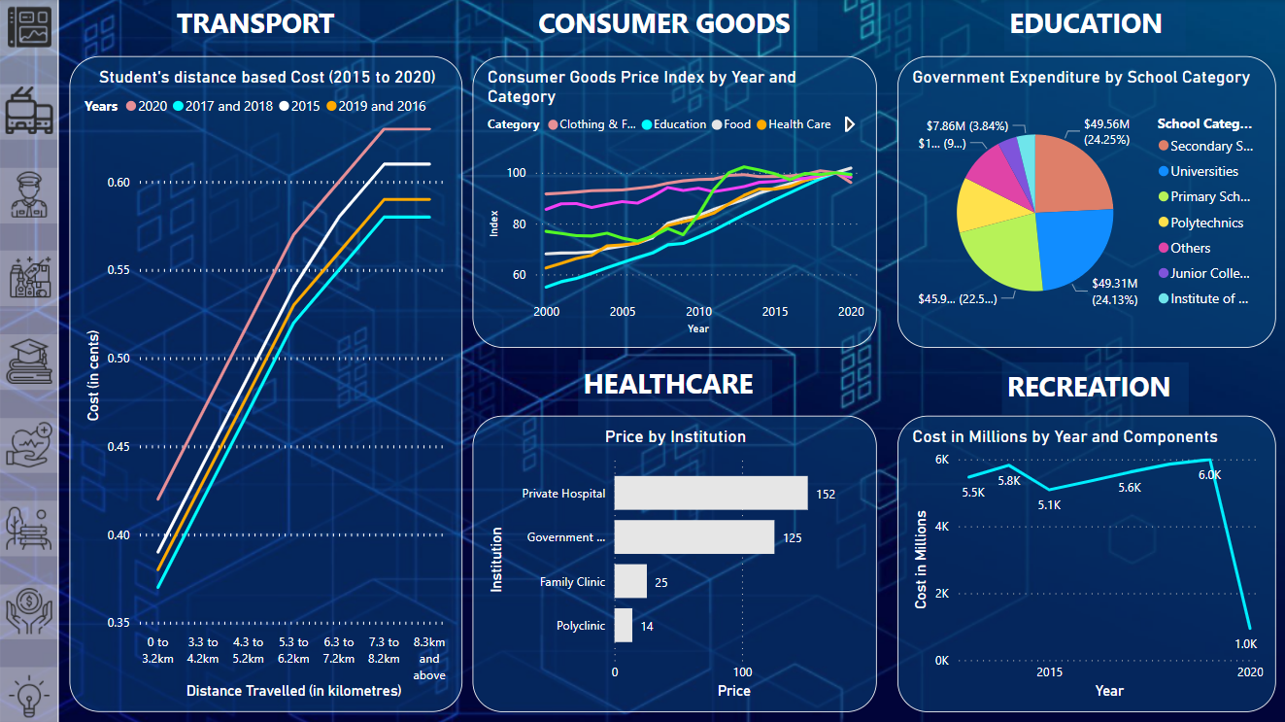

Figure 0 – Dashboard on Affordability

1. Transportation:

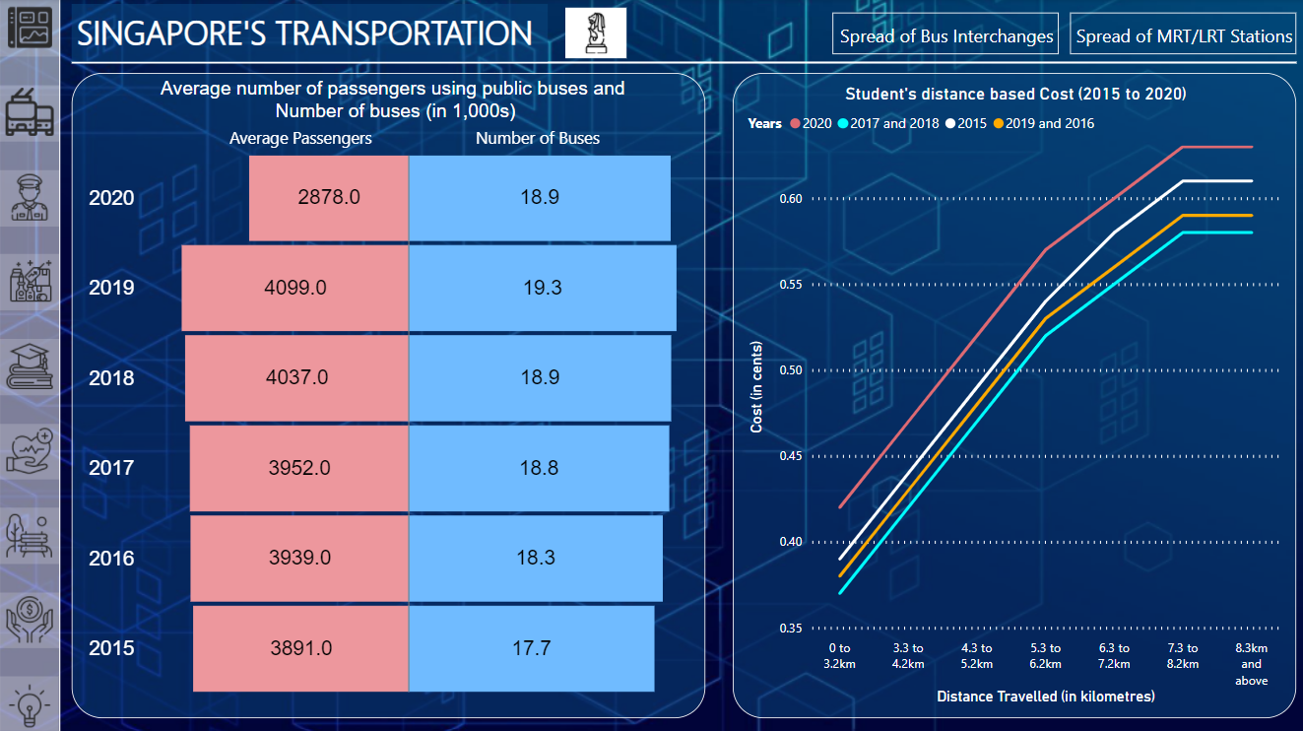

Figure 1.1 - Buses and Fares

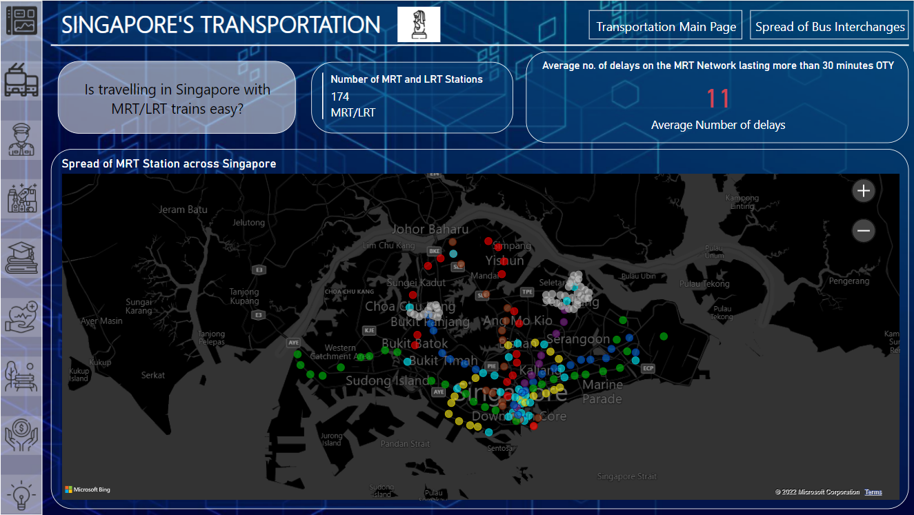

Figure 1.2 - MRT Map

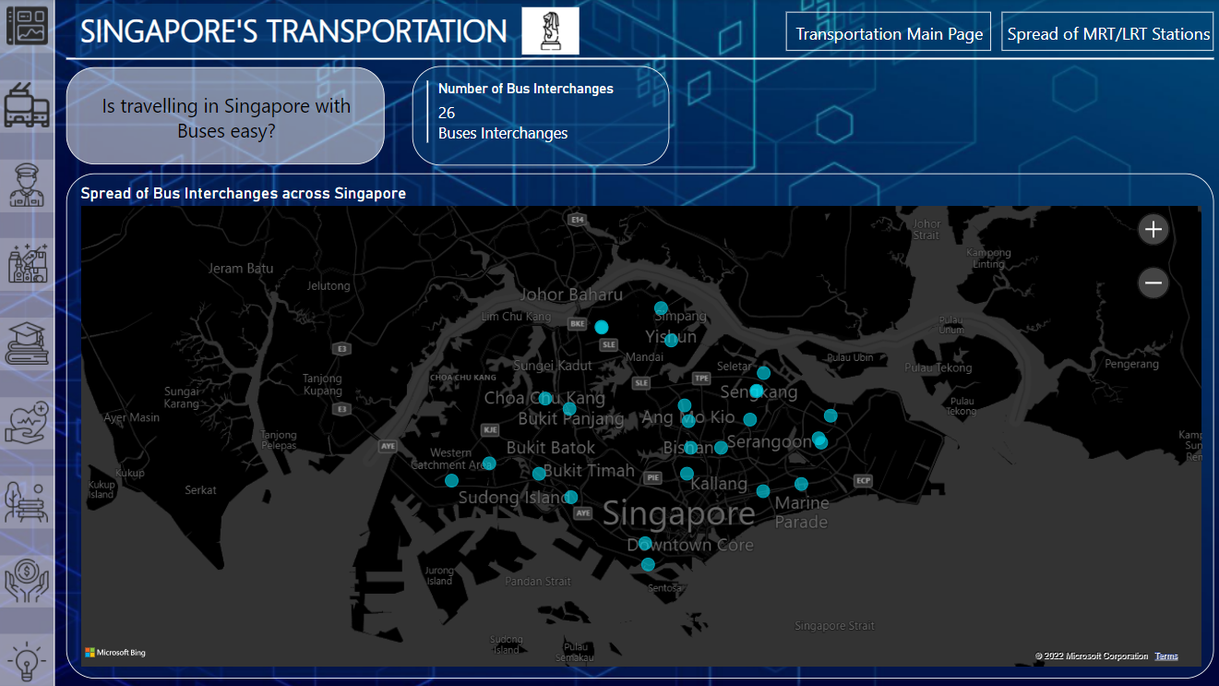Figure 1.3 - Bus Map

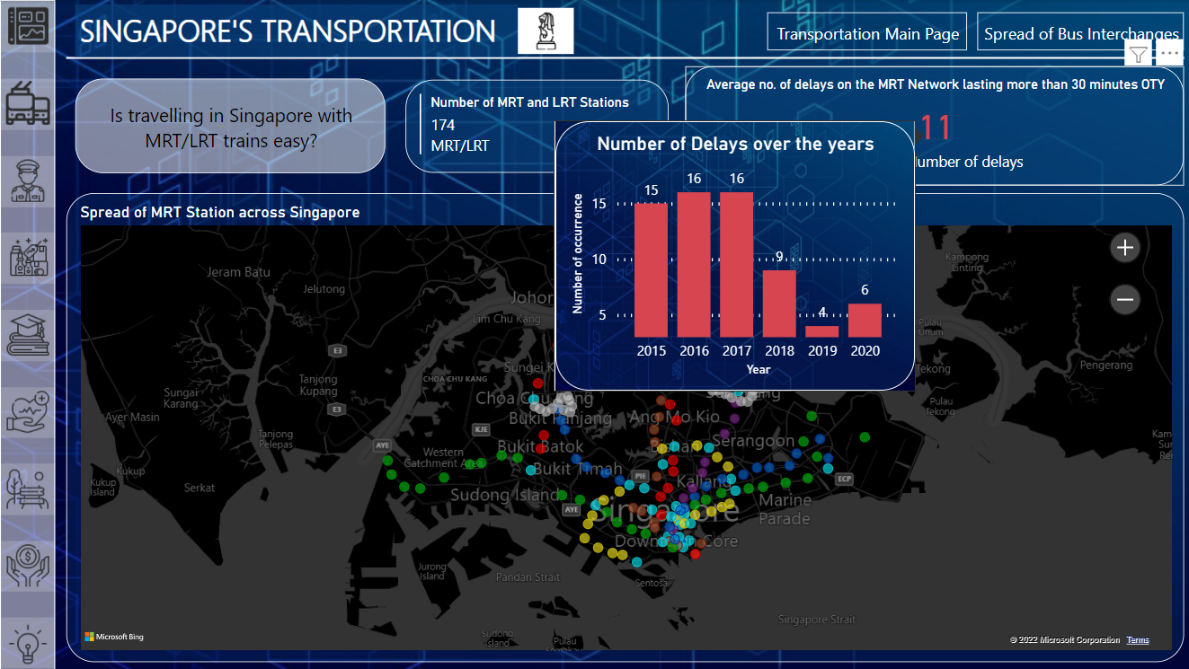Figure 1.4 - Hovered Card

1. Security:

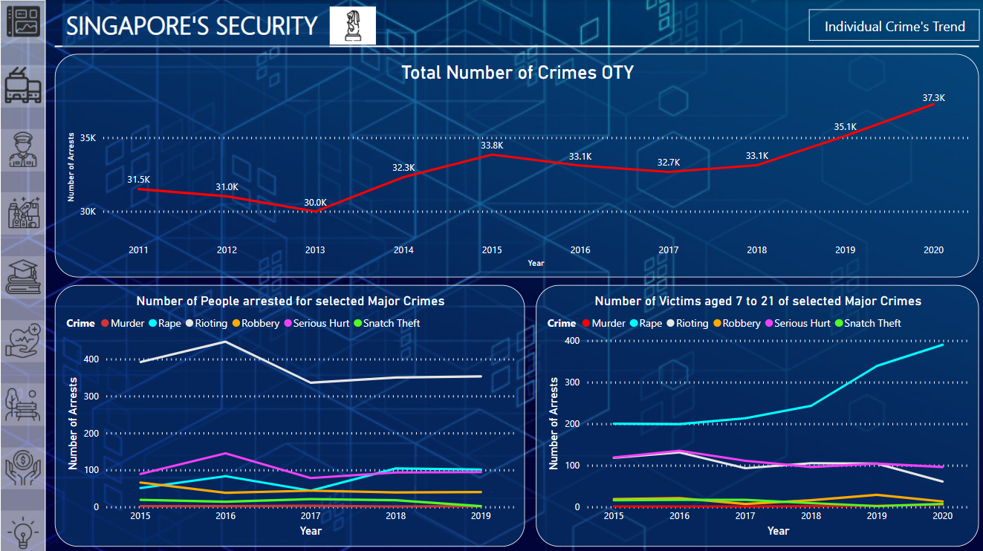Figure 2.1 - Crime

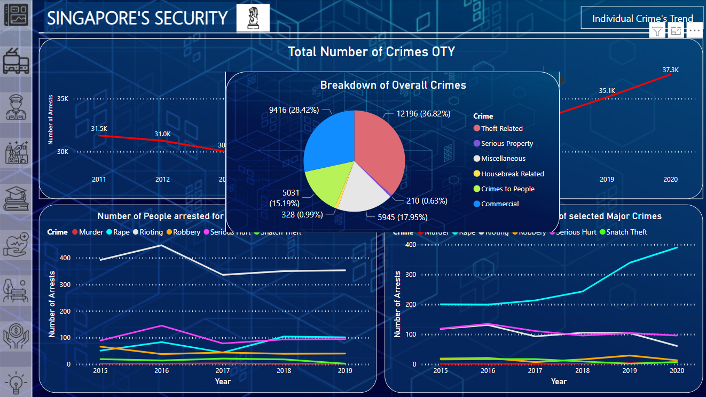Figure 2.2 - Hovered Crime

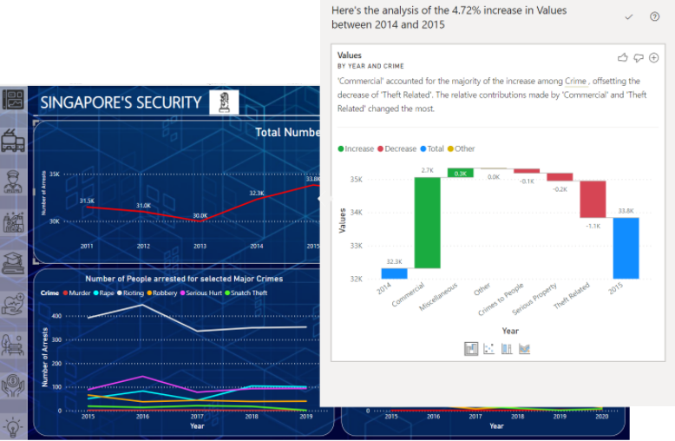

Figure 2.3 - Crime Analyze

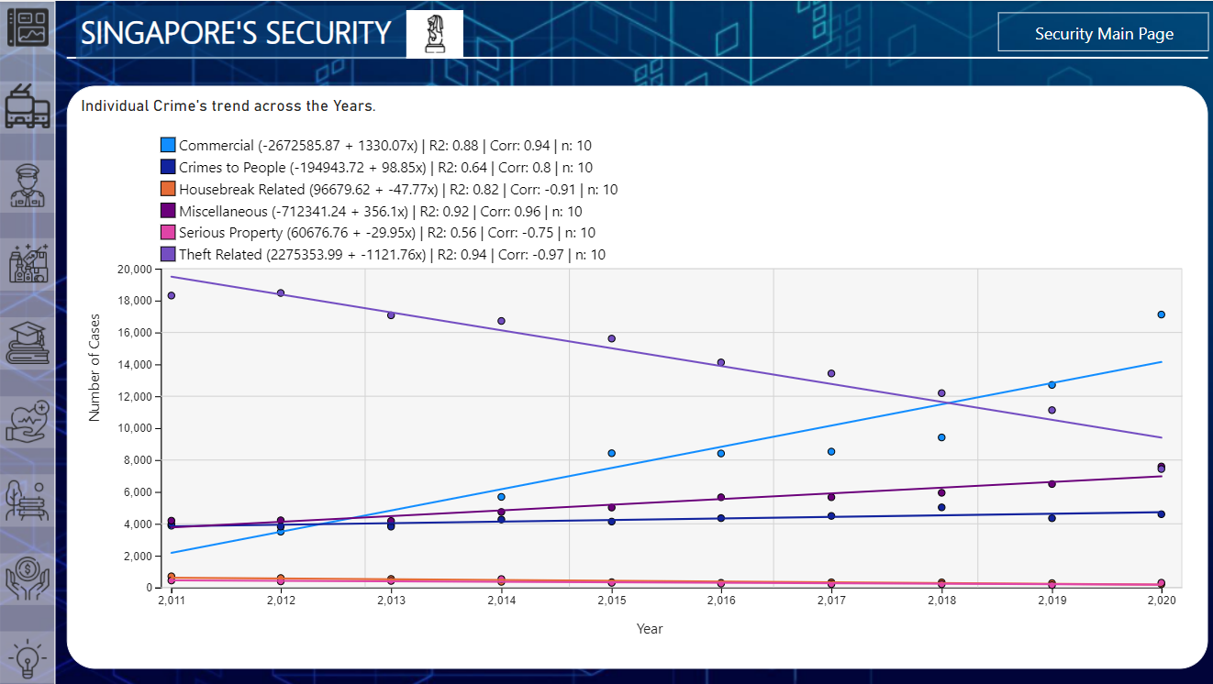Figure 2.4 - Crime Regression

1. Consumer Goods

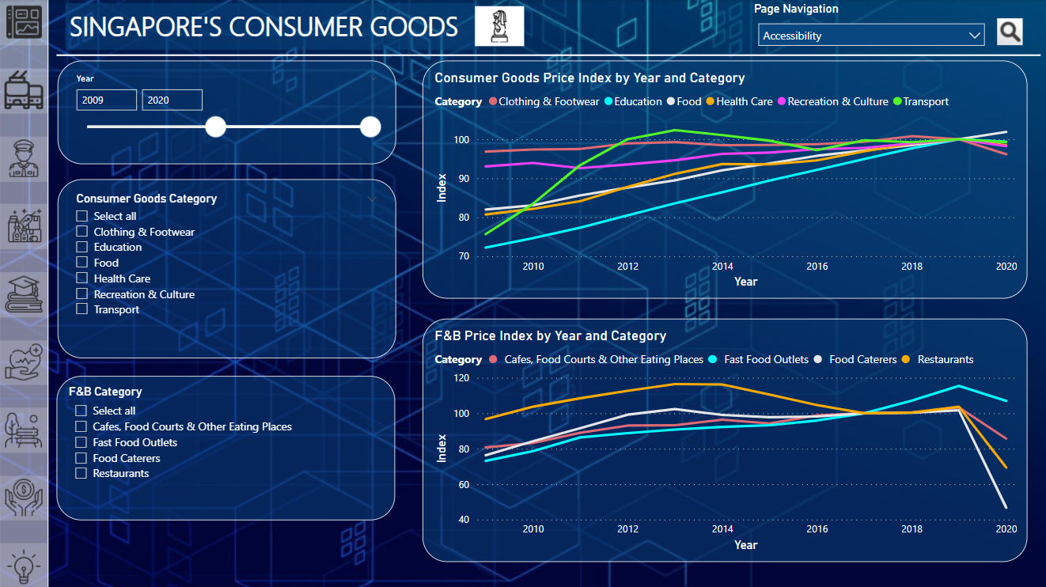Figure 3.1 - Consumer Goods Affordability Price Index

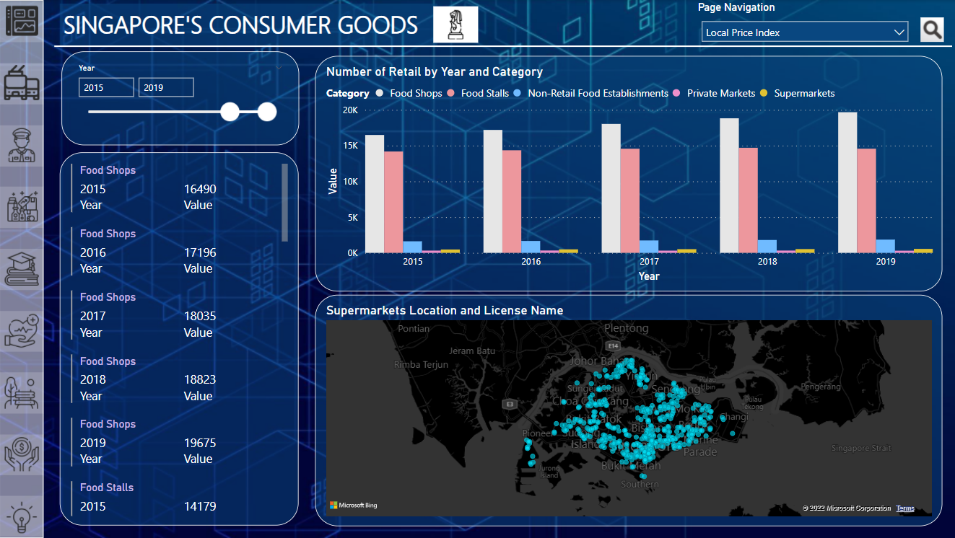Figure 3.2 - Consumer Goods Accessibility

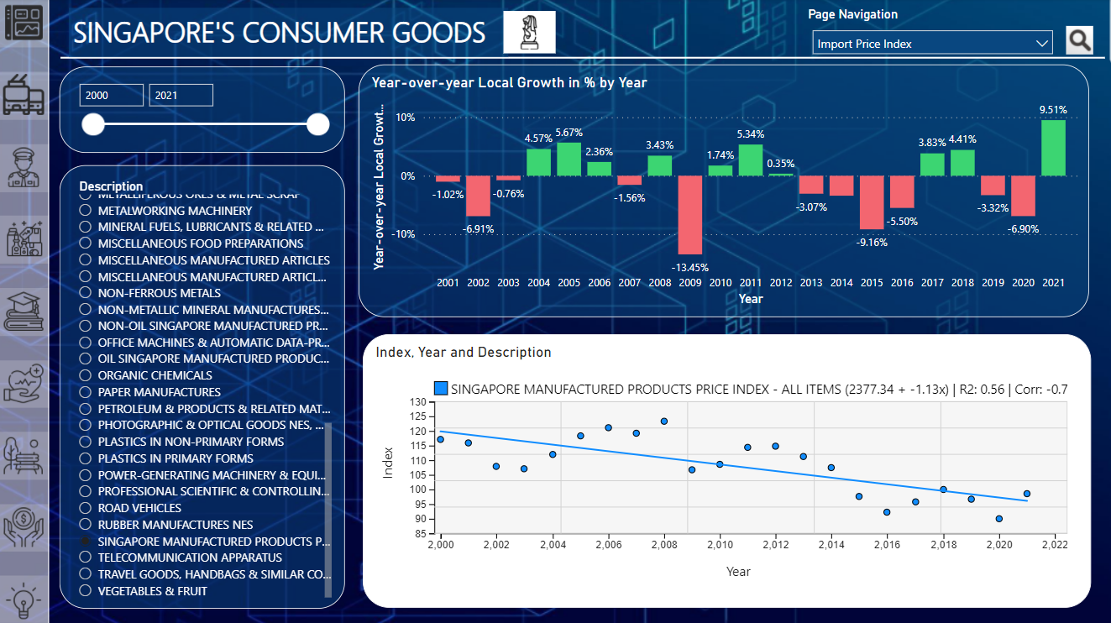Figure 3.3 - Local Goods Price Index

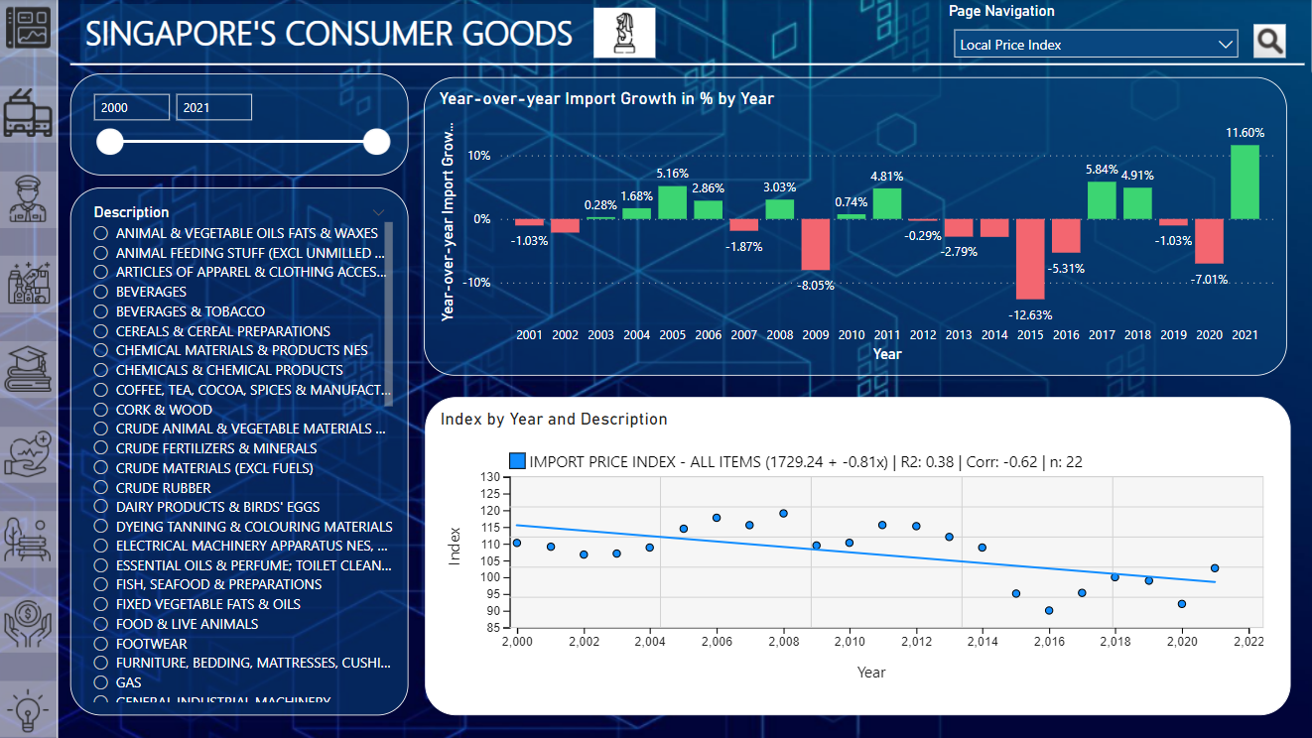Figure 3.4 - Imported Goods Price Index

1. Education:

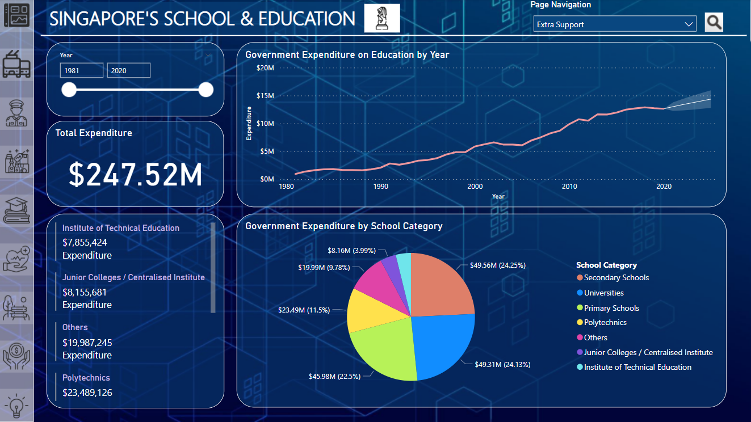Figure 4.1 - Education Subsidies

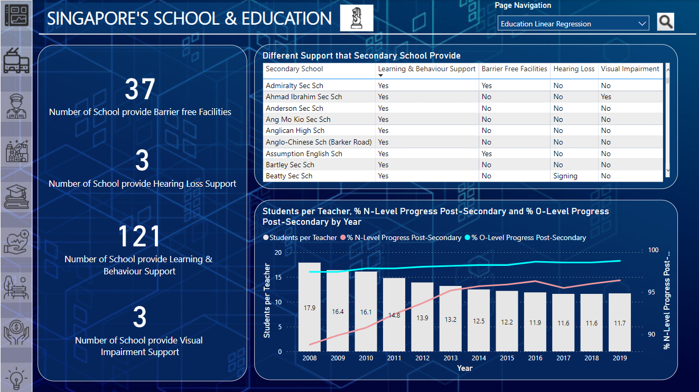Figure 4.2 - Education Support

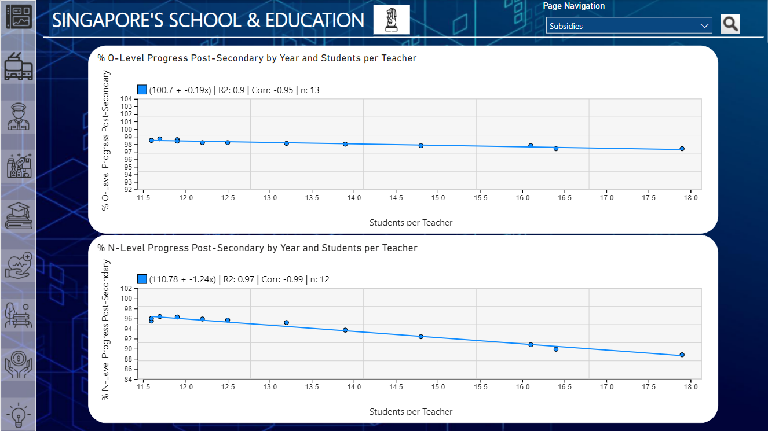Figure 4.3 - Linear Regression on Students per Teacher and Progress Rate

1. Healthcare:

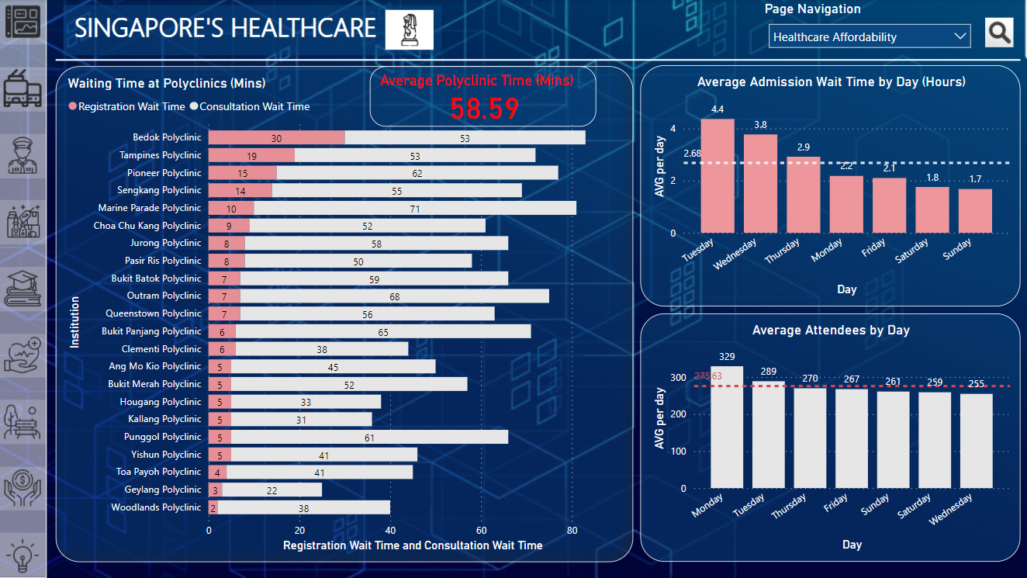Figure 5.1 - Healthcare Waiting Time

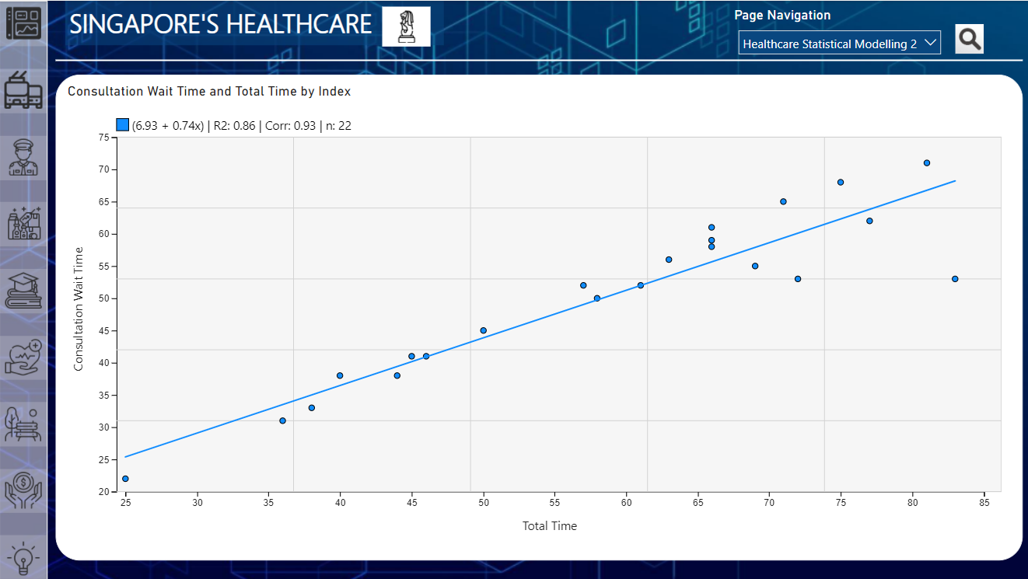Figure 5.2 - Healthcare Regression 1

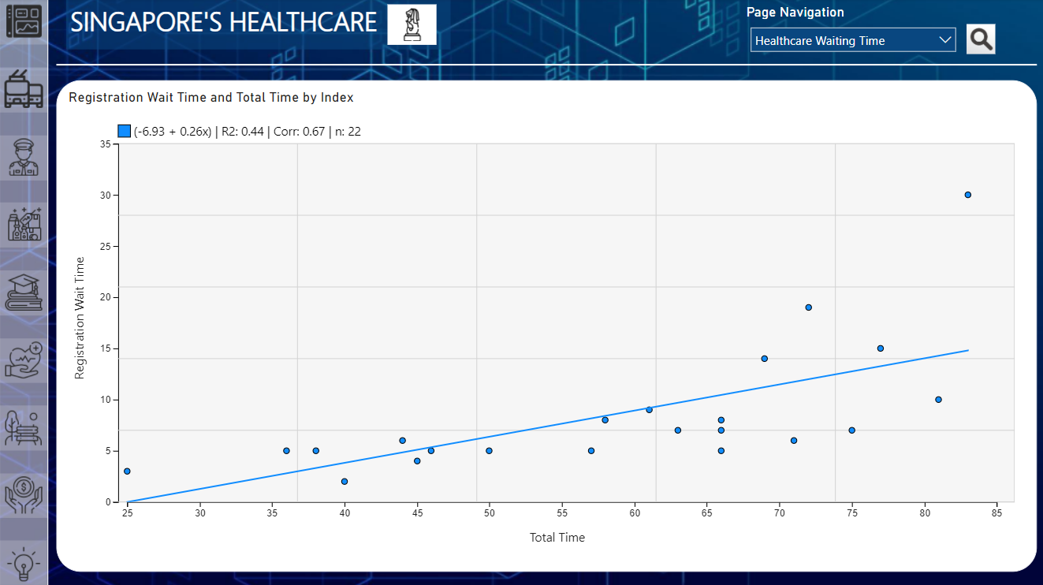Figure 5.3 - Healthcare Regression 2

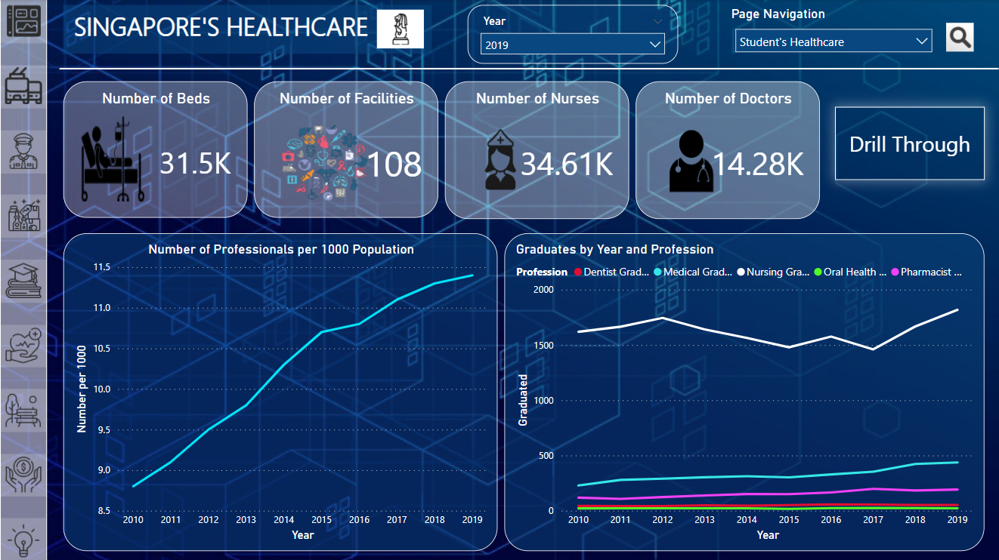Figure 5.4 - Healthcare Professionals and Facilities

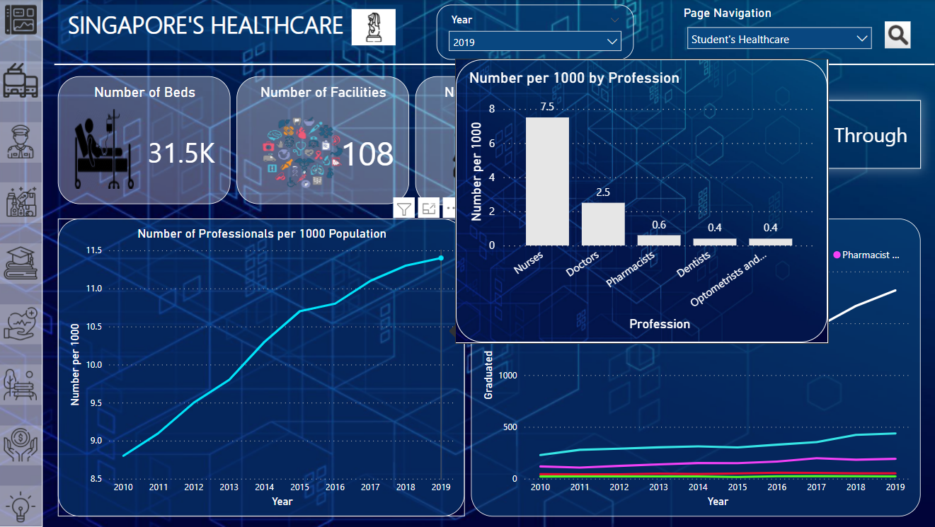Figure 5.5 - Healthcare Professionals

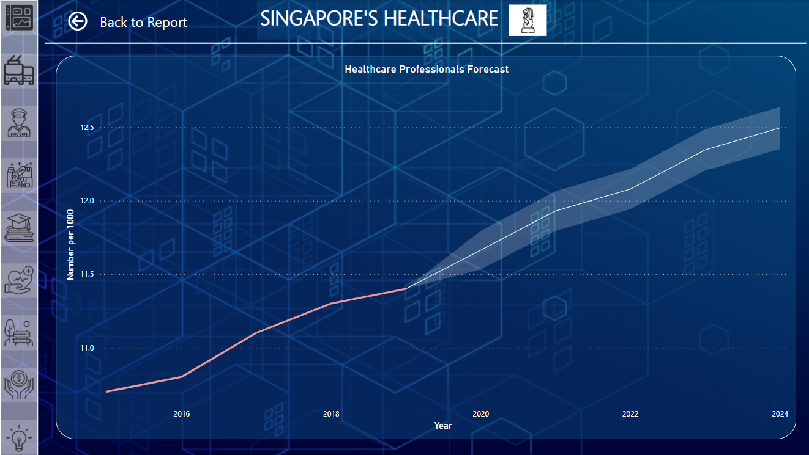Figure 5.6 - Healthcare Forecast

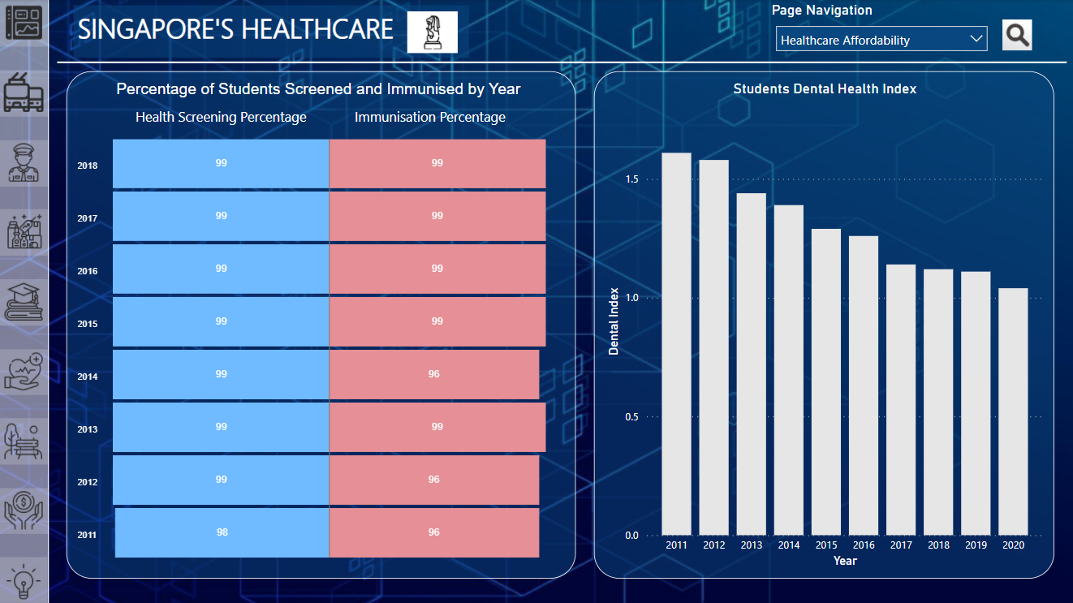Figure 5.7 - Students’ Healthcare

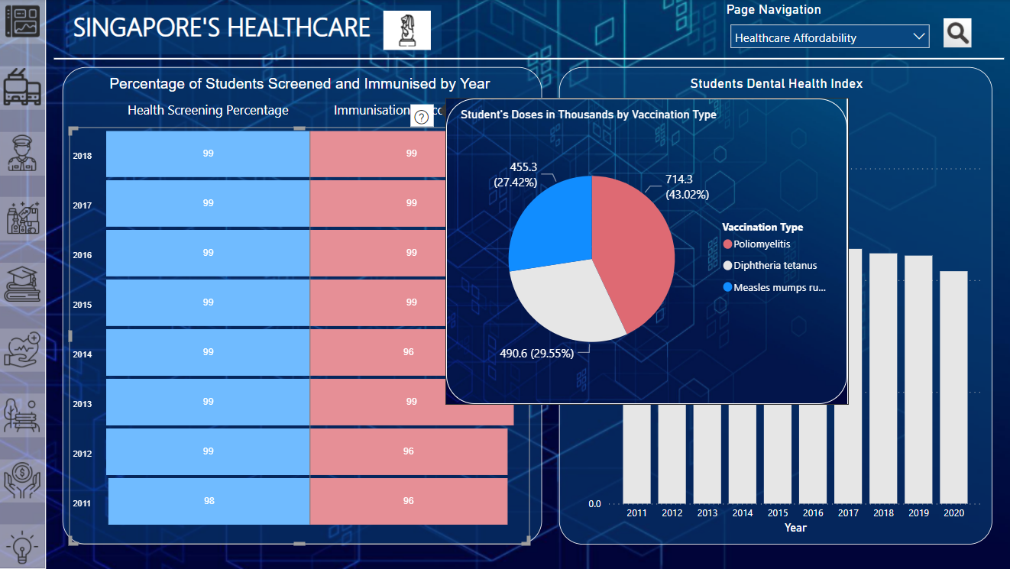Figure 5.8 - Students’ Healthcare Tooltip

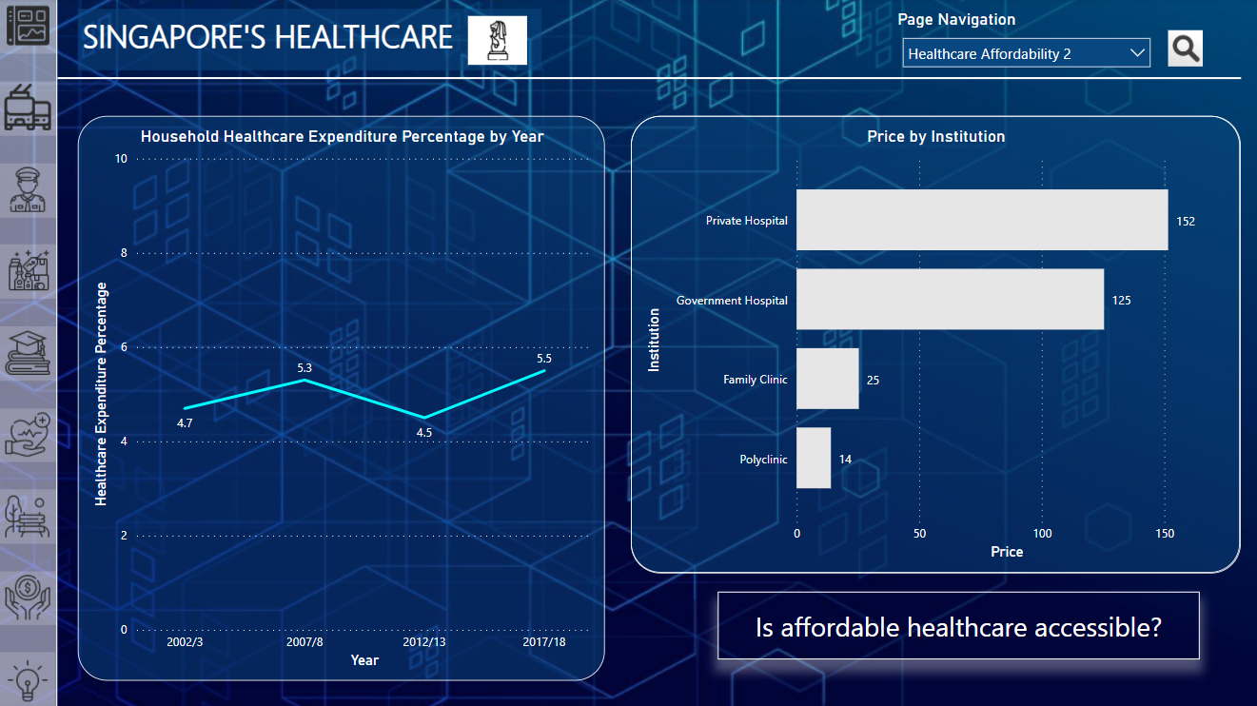Figure 5.9 - Healthcare Affordability 1

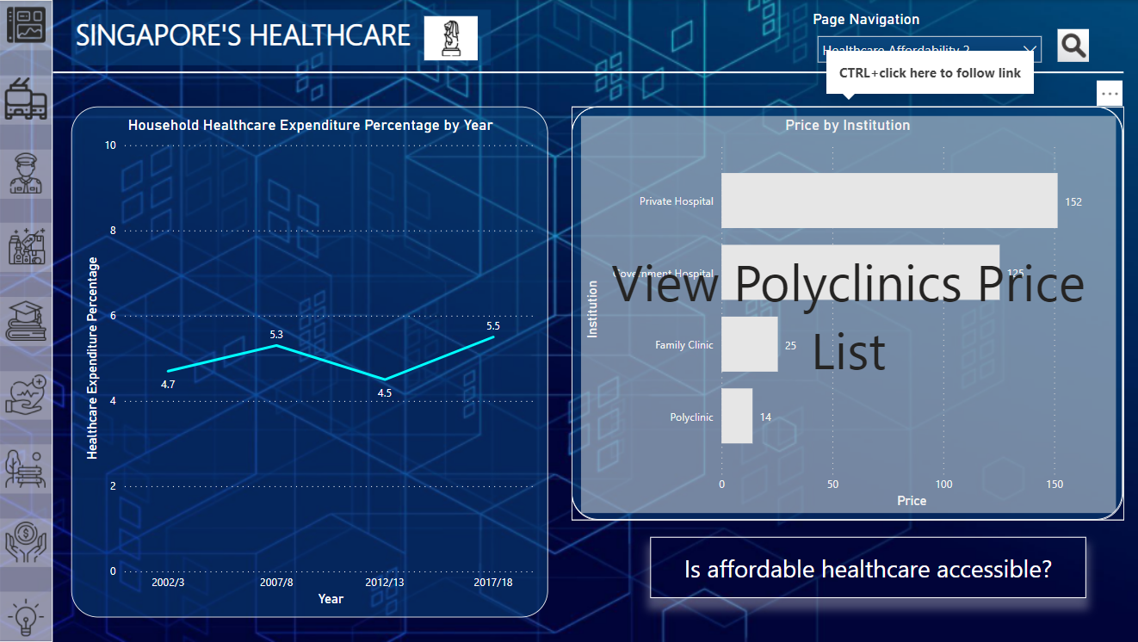Figure 5.10 - Healthcare Affordability 1 Link

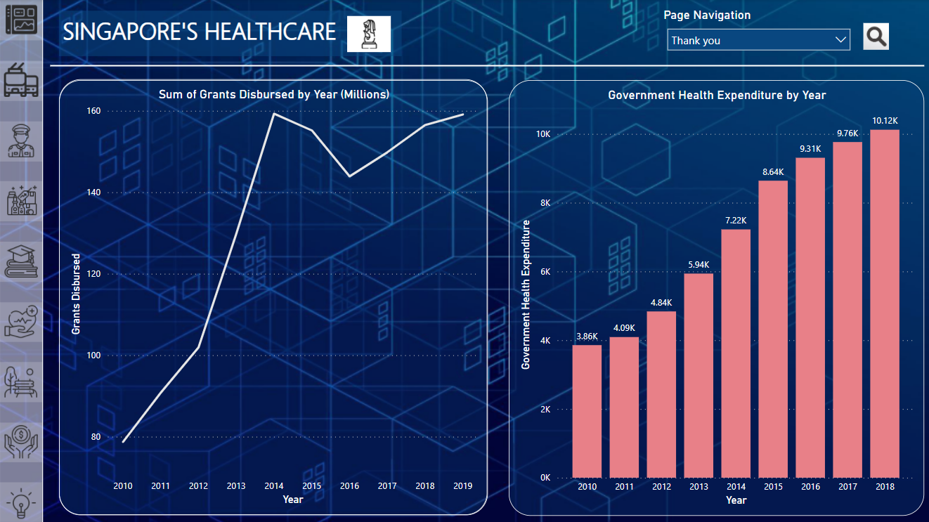

Figure 5.11 - Healthcare Affordability 2

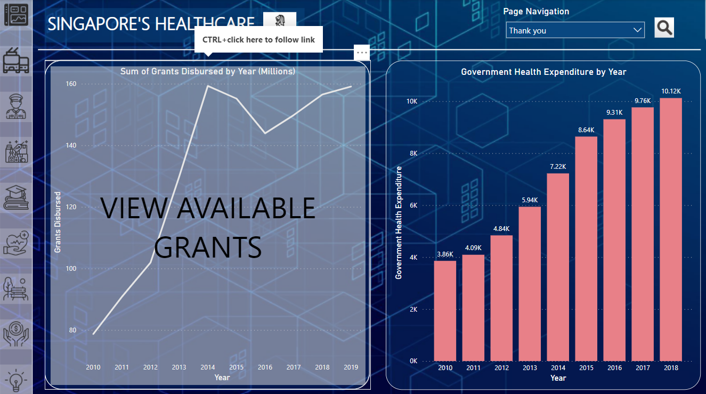Figure 5.12 - Healthcare Affordability 2 Link

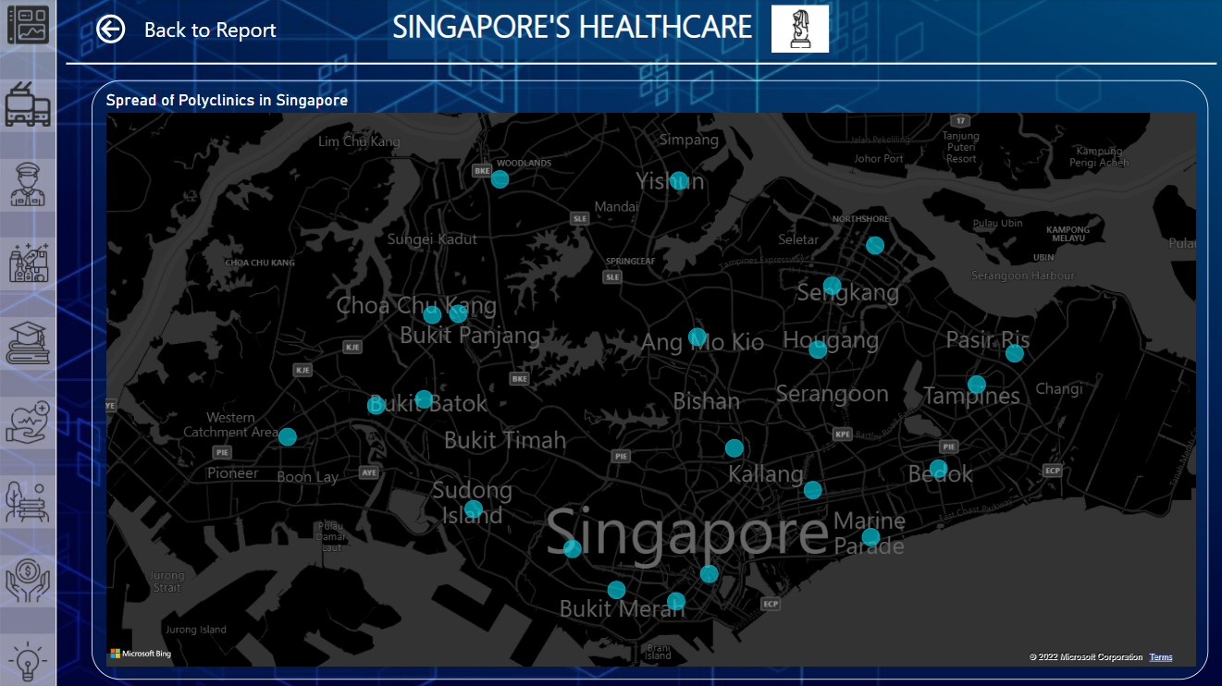Figure 5.13 - Spread of Polyclinic Map

1. Recreation:

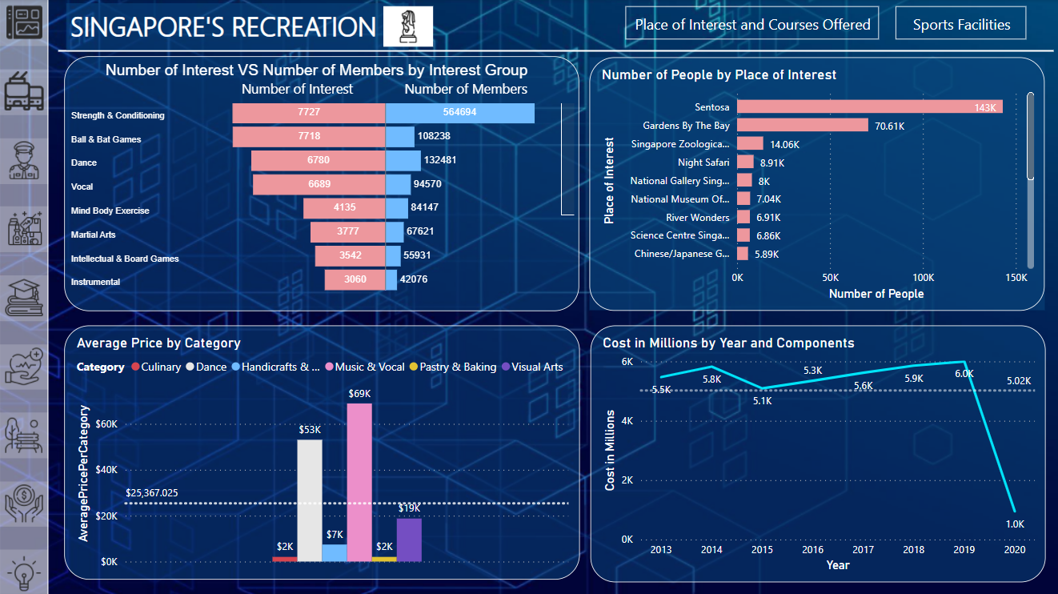Figure 6.1 - Places of Interest and Courses Offered

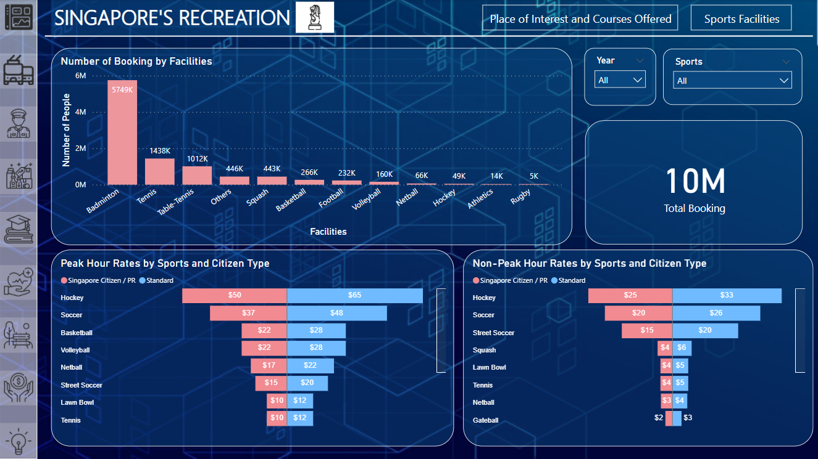Figure 6.2 - Sports Facilities

1. Economy:

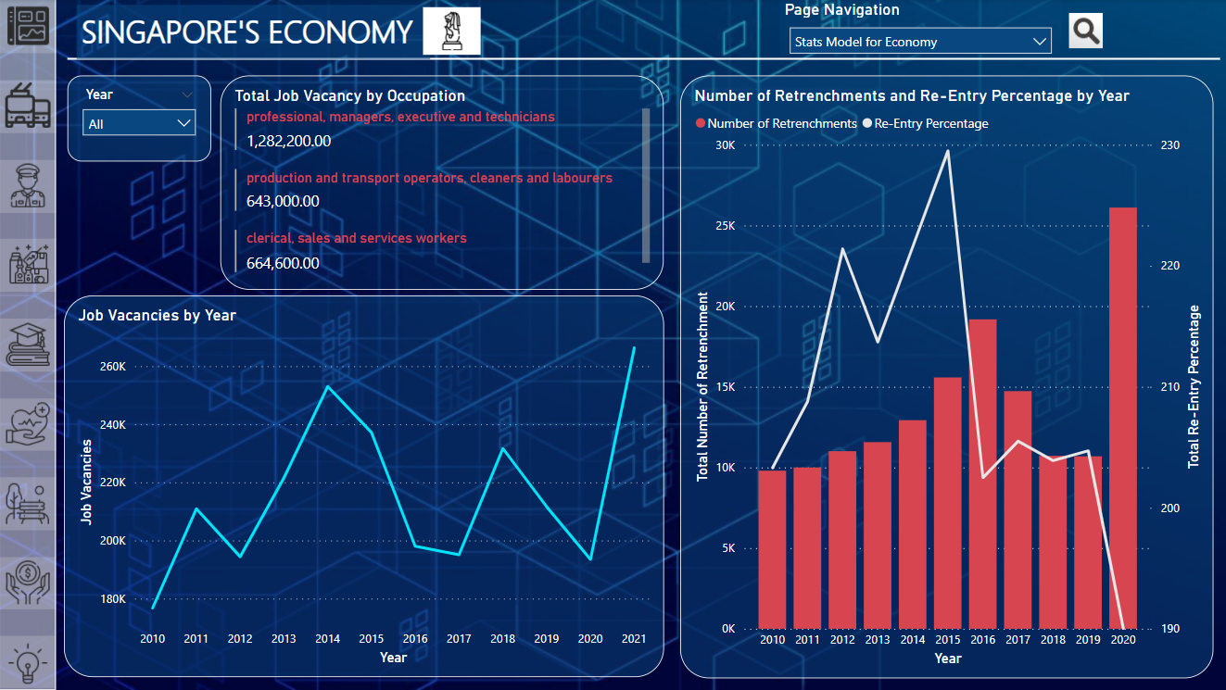Figure 7.1 - Job Vacancy and Retrenchment

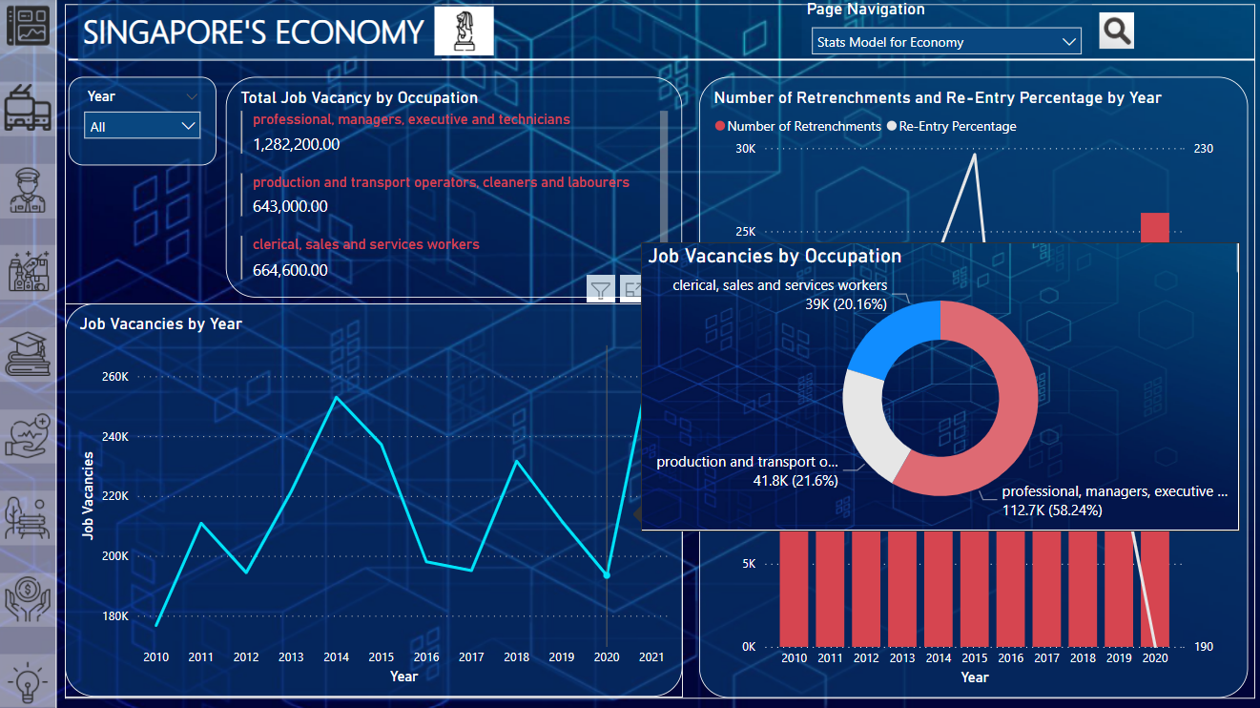Figure 7.2 - Job Vacancy Hover Effect

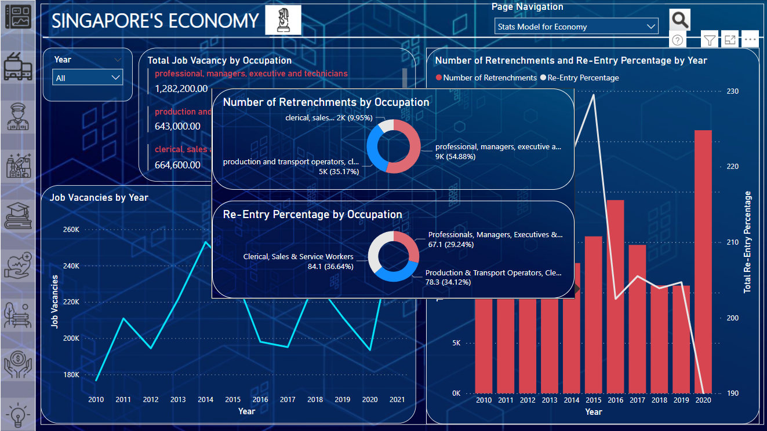Figure 7.3 - Number of Retrenchment and Re-Entry Percentage Hover Effect

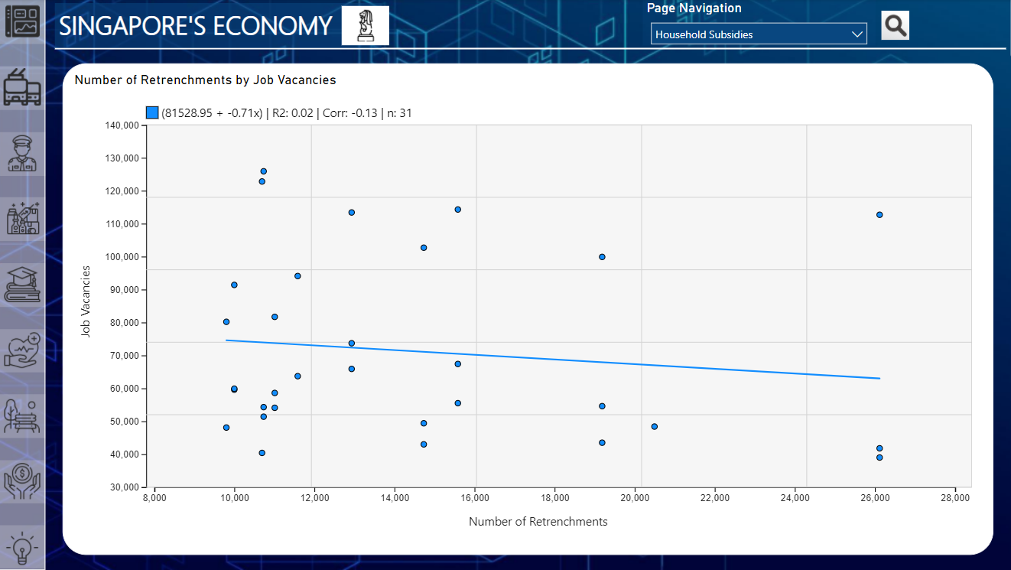Figure 7.4 - Number of Retrenchment by Job Vacancy Regression

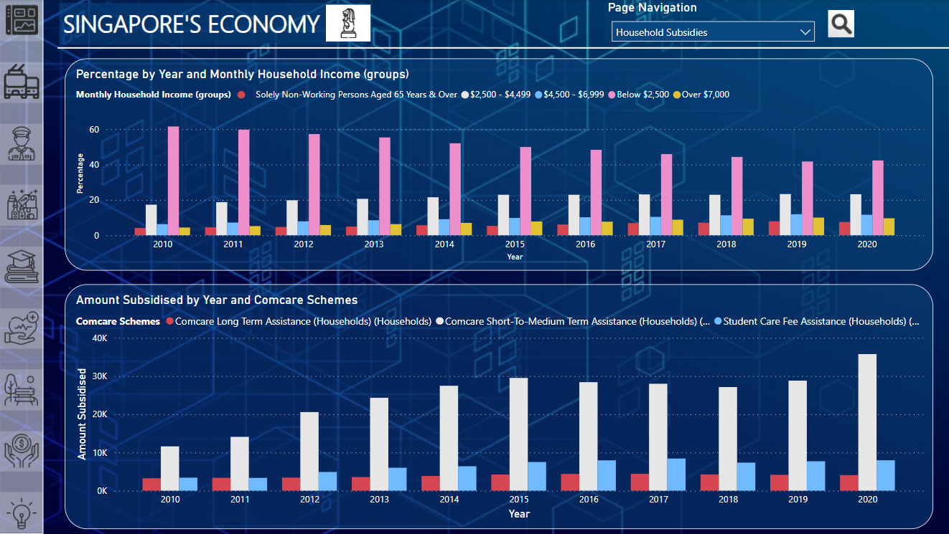Figure 7.5 - Household Income and Subsidies Provided